**Qiuying Li**

**UNI: ql2280**

**HW6**

Problem 1

Consider comparing Diet Levels 1 and 2 on Day 21.

(a). Determine whether there is association between Diet and Weight, using logistic regression, without adjusting for Birth Weight. Interpret what the estimated parameters denote.

|  |
| --- |
| Logistic Regression without adjust result  ##Call:  ##glm(formula = Weight ~ Group, family = "binomial", data = sub_day21)  ## Deviance Residuals:  ## Min 1Q Median 3Q Max  ## -1.48230 -1.01077 -0.05513 1.01382 1.35373  ##  ## Coefficients:  ## Estimate Std. Error z value Pr(>|z|)  ## (Intercept) -0.4055 0.6455 -0.628 0.530  ## Group 1.0986 1.0801 1.017 0.309  ##  ## (Dispersion parameter for binomial family taken to be 1)  ##  ## Null deviance: 22.181 on 15 degrees oxf freedom  ## Residual deviance: 21.098 on 14 degrees of freedom  ## AIC: 25.098  ##  ## Number of Fisher Scoring iterations: 4 |

The model is:  logit(p) = -0.4055 + 1.0986 ∗ Group

For Diet group 1, the model is:

logit(p) = -0.4055 +1.0986 = 0.6931

For Diet group 4, the model is:

logit(p) = -0.4055

There are two parameters here, intercept β0, and coefficient β1 on Diet group.

• β0 denotes the log odds ratio of Weight <180 for Diet group 4, i.e., the odds ratio of Weight <180 for Diet group 4 is e-0.4055.

• β1 denotes the log odds ratio of Weight <180 for Diet group 1 relative to Diet Group 4, i.e., odds ratio of Weight <180 for Diet group 1 relative to Diet Group 4 is e1.0986, and also the odds ratio of Weight <180 for Diet group 1 is e0.6931.

Since p-value for the intercept and Group are both p-value > 0.05, so we don’t reject the null, i.e., there are no significant association between Diet Group 1 and 4 and Categorical Weight without adjusting for BirthWeight.

(b). Repeat (a) adjusting for Birth Weight. Interpret what the estimated parameters denote. Construct a logistic regression model without adjusting for Birth Weight with Weight for Diet group 1 and 2 on day 21. Restructure the data as categorical data type. The response and explanatory variable is like:

|  |
| --- |
| Logistic Regression with adjust result  ##Call:  ## glm (formula = Weight ~ Group + BirthWeight, family = "binomial",  data = sub_day21)  ##  ## Deviance Residuals:  ## Min 1Q Median 3Q Max  ## -1.83779 -0.41249 0.01454 0.63916 1.38171  ##  ## Coefficients:  ## Estimate Std. Error z value Pr(>|z|)  ## (Intercept) -80.539 42.885 -1.878 0.0604 .  ## Group 0.597 1.431 0.417 0.6765  ## BirthWeight 1.953 1.038 1.882 0.0598 .  ## ---  ## Signif. codes: 0 '***' 0.001 '**' 0.01 '*' 0.05 '.' 0.1 ' ' 1  ##  ## (Dispersion parameter for binomial family taken to be 1)  ##  ## Null deviance: 22.181 on 15 degrees of freedom  ## Residual deviance: 12.414 on 13 degrees of freedom  ## AIC: 18.414  ##  ## Number of Fisher Scoring iterations: 6 |

The model is:

logit(p) = -80.539 − 0.597 ∗ Group − 1.953 ∗ BirthWeight

So for Diet group 1 the model is:

logit(p) = -80.539+0.597+1.953*BirthWeight = -79.942+1.953*BirthWeight

for Diet group 2 the model is:

logit(p) = -80.539+1.953*BirthWeight

There are three parameters here, intercept β0, and coefficient β1 on Diet group, and coefficient β2 on BirthWeight.

• β0 denotes when BirthWeight is given 0, the log odds ratio of Weight <180 for Diet group 2, i.e., when BirthWeight=0(which is not realistic), the odds ratio of Weight <180 for Diet group 2 is e-80.539, and the odds ratio of Weight <180 for Diet group 4 when given BirthWeight = x is e-80.539 − 0.597 ∗ Group.

• β1 denotes the log odds ratio of Weight <180 for Diet group 1 relative to Diet Group 2 when given BirthWeight = 0(which is not realistic), i.e., when BirthWeight = 0 odds ratio of Weight <180 for Diet group 1 relative to Diet Group 2 is e1.953, and odds ratio of Weight <180 for Diet group 1 when given BirthWeight is e-79.942+1.953*BirthWeight

• β2 denotes under same Diet Group, the change in log odds for Weight <180 when the BirthWeight is different, i.e., under same Diet Group, 1 unit change in BirthWeight will cause the odds for Weight <180 in day 21 change e1.953.

Since p-value for the intercept, Group and BirthWeight are all p-value > 0.05, so we don’t reject the null, i.e., there are no significant association between Diet Group 1 and 2 and Categorical Weight with adjusting for BirthWeight.

Problem 2

Repeat 1 for all 4 Diet Levels. (a). Without adjusting for BirthWeight.

Construct a logistic regression model without adjusting for Birth Weight with Weight for Diet group 1 and 4 on day 21. Restructure the data as categorical data type. The response and explanatory variable is like:

Repeat 1 for all 4 Diet Levels.

2. (a). Without adjusting for BirthWeight.

|  |
| --- |
| Logistic Regression without adjust result  ## Call:  ## glm(formula = biweight ~ Group1 + Group2 + Group3, family = "binomial",  ## data = sub.all)  ## Deviance Residuals:  ## Min 1Q Median 3Q Max  ## -1.28583 -1.01077 -0.00013 1.07272 1.79412  ## Coefficients:  ## Estimate Std. Error z value Pr(>|z|)  ## (Intercept) -18.57 2174.21 -0.009 0.993  ## Group1 18.82 2174.21 0.009 0.993  ## Group2 18.16 2174.21 0.008 0.993  ## Group3 17.18 2174.21 0.008 0.994  ## (Dispersion parameter for binomial family taken to be 1)  ## Null deviance: 57.286 on 44 degrees of freedom  ## Residual deviance: 45.398 on 41 degrees of freedom  ## AIC: 53.398  ##  ## Number of Fisher Scoring iterations: 17 |

The model is:

logit(p) = -18.57+18.82*Group1+18.16*Group2+17.18*Group3

For Diet1, logit(p)=-18.57+18.82=0.25

For Diet2, logit(p)=-18.57+18.16=-0.41

For Diet3, logit(p)=-18.57+17.18=-1.39

For Diet4, logit(p)=-18.57

There are four parameters here, intercept β0, and coefficient β1 on Diet group1, coefficient β2 on Diet group2, coefficient β3 on Diet group3.

• β0 denotes the log odds ratio of Weight <180 for Diet group 4, i.e., the odds ratio of Weight <180 for Diet group 4 is e-18.57.

• β1 denotes the log odds ratio of Weight <180 for Diet group 1 relative to Diet Group 4, i.e., odds ratio of Weight <180 for Diet group 1 relative to Diet Group 4 is e18.82, and odds ratio of Weight <180 for Diet group 1 is e0.25.

• β2 denotes the log odds ratio of Weight <180 for Diet group 2 relative to Diet Group 4, i.e., odds ratio of Weight <180 for Diet group 2 relative to Diet Group 4 is e18.16, and odds ratio of Weight <180 for Diet group 2 is e0.41 .

• β3 denotes the log odds ratio of Weight <180 for Diet group 3 relative to Diet Group 4, i.e., odds ratio of Weight <180 for Diet group 3 relative to Diet Group 4 is e17.18, and odds ratio of Weight <180 for Diet group 3 is e-1.39.

Since p-value for the intercept, Group1, Group2, Group3 are all p-value > 0.05, so we don’t reject the null, i.e., there are no significant association between Diet Group from 1 to 4 and Categorical Weight without adjusting for BirthWeight.

2. (b). With adjusting for BirthWeight.

Construct a logistic regression model without adjusting for Birth Weight with Weight for Diet group 1 and 4 on day 21. Restructure the data as categorical data type. The response and explanatory variable is like:

|  |
| --- |
| Logistic Regression with adjust result  ## Call:  ## glm(formula = biweight ~ Group1 + Group2 + Group3 + BirthWeight,  ## family = "binomial", data = sub.all.birth)  ## Deviance Residuals:  ## Min 1Q Median 3Q Max  ## -1.72563 -0.80750 -0.00018 0.94758 2.35262  ## Coefficients:  ## Estimate Std. Error z value Pr(>|z|)  ## (Intercept) -45.8699 2079.4814 -0.022 0.9824  ## Group1 18.4977 2079.4211 0.009 0.9929  ## Group2 18.3069 2079.4211 0.009 0.9930  ## Group3 17.2229 2079.4212 0.008 0.9934  ## BirthWeight 0.6652 0.3827 1.738 0.0822 .  ## Signif. codes: 0 '***' 0.001 '**' 0.01 '*' 0.05 '.' 0.1 ' ' 1  ## (Dispersion parameter for binomial family taken to be 1)  ## Null deviance: 57.286 on 44 degrees of freedom  ## Residual deviance: 41.904 on 40 degrees of freedom  ## AIC: 51.904  ## Number of Fisher Scoring iterations: 17 |

the model

logit(p) = -45.8699+18.49772*Group1+18.3069*Group2+17.2229*Group3+0.6652*birthweight

For Diet1, logit(p)=-45.8699+18.49772+0.6652*birthweight

For Diet2, logit(p)=-45.8699+18.3069+0.6652*birthweight

For Diet3, logit(p)=-45.8699+17.2229+0.6652*birthweight

For Diet4, logit(p)=-45.8699+0.6652*birthweight

There are five parameters here, intercept β0, and coefficient β1 on Diet group1, coefficient β2 on Diet group2, coefficient β3 on Diet group3, and coefficient β4 on BirthWeight.

• β0 denotes the log odds ratio of Weight < 180 for Diet group 4 under given BirthWeight=0(which is not realistic), i.e., the odds ratio of Weight < 180 for Diet group 4 when BirthWeight=0 is e-45.8699, and the odds ratio of Weight < 180 for Diet group 4 under given BirthWeight is e-45.8699 + 0.6652*birthweight.

• β1 denotes when BirthWeight=0, odds ratio of Weight < 180 for Diet group 1 relative to Diet Group 4 is e-27.37218, and under given BirthWeight = x odds ratio of Weight < 180 for Diet group 1 relative to Diet Group 4 is e-27.37218 + 0.6652*birthweight.

• β2 denotes when BirthWeight=0, odds ratio of Weight < 180 for Diet group 2 relative to Diet Group 4 is e-27.563, and under given BirthWeight = x odds ratio of Weight < 180 for Diet group 2 relative to Diet Group 4 is e-27.5638 + 0.6652*birthweight.

• β3 denotes when BirthWeight=0, odds ratio of Weight < 180 for Diet group 2 relative to Diet Group 4 is e-28.647, and under given BirthWeight = x odds ratio of Weight < 180 for Diet group 3 relative to Diet Group 4 is e-28.647 + 0.6652*birthweight

• β4 denotes under same Diet Group, the change in log odds for Weight < 180 when the BirthWeight is changing, i.e., under same Diet Group, 1 unit change in BirthWeight will cause the odds for Weight < 180 in day 21 change e0.6652.

Since p-value for the intercept, Group1, Group2, Group3 and BirthWeight are all p-value > 0.05, so we don’t reject the null, i.e., there are no significant association between Diet Group from 1 to 4 and Categorical Weight with adjusting for BirthWeight.

Problem 3

Repeat 1 using the L-1 regularized logistic regression.

We should use Birth Weight and Group for L-1 logistic regression. The cross-validation plot of choosing best gamma is as follows:

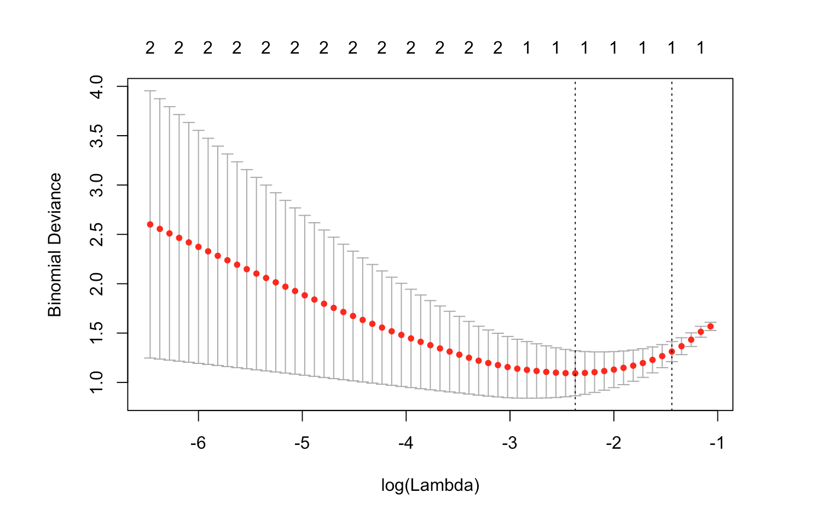

Then, choose the best lambda, lambda = 0.03921473, and get the model with the best lambda. The coefficients are as follows:

|  |
| --- |
| Coefficients of L-1 Logistic Regression  ## 3 x 1 sparse Matrix of class "dgCMatrix"  ## 1  ## (Intercept) -39.88938  ## BirthWeight 0.97229  ## Group .  So, the final model is: logit(p) = -39.88938 + 0.97229 ∗ BirthWeigh |